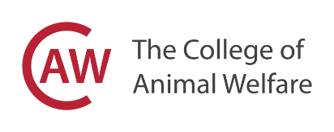
COVID-19 RISK REVIEW

Please complete below and return to covidsymptoms@caw.ac.uk

Name:
College Centre:
Course:
Date notified The College of Animal Welfare: (symptoms or/in contact with another person tested positive)
Date COVID-19 symptoms shown:
(if applicable)
Have you had a COVID-19 test
Have you tested positive for COVID-19:
Date isolation period started:
Who you have been in contact with in centre
(staff):
Who have you been in contact with in centre (students):
Activity completed at the College/rooms entered:
Have you advised your practice/placement:
Have you received notification from NHS Test and Trace? (date):
Date isolation finishes:
Any other relevant details:

